**Submarine fan**

* Deposited by sediment gravity flow processes ( channelized turbidity currents, debris flow)
* Components:
  + Upper fan – contains a major feeder channel
  + Middle fan – contains a network of distributary channels and associated overbanks
  + Lower fan – contains lobes or sheet sand
* Reservoir potential: channels and lobes

|  |  |  |  |  |  |  |
| --- | --- | --- | --- | --- | --- | --- |
|  | **Transport processes** | **Lithology** | **Sedimentary features** | **Turbidite facies** | **Grain size trend** | **Bed thickness trend** |
| **Channel** | Slumps, debris flows, turbidity currents | Conglomerate, sandstone, mudstone | Erosive bases, rip-up clasts, lenticular sand bodies | A (Sediments deposited from cohesive debris flows),  B (Coarse-grained sandy turbidites) | fining upward | thinning upward |
| **Lobe (lobe complexes)** | turbidity currents | Sandstone, mudstone | Complete and partial Bouma sequence, continuous sand bodies | C (Medium-grained sandy turbidites), D (Fine-grained sandy/muddy turbidites) | coarsening upward | thickening upward |
| **channel lobe transition zone** | Suspension |  | Erosional/bypass features  such as furrows, scours and sand waves | E |  |  |
| **Overbanks** |  |  |  | E |  |  |
| **Slope** |  |  | Slump | F |  |  |
| **Basin plain** |  | Hemipelagites |  | G |  |  |

**Bouma sequence**:

**Facies classification** (Mutti and Ricci Lucchi, 1972,1975):

* Facies A – conglomerate, pebbly sandstones, pebbly mudstone
  + Moderate reservoir potential because of abundand depositional matrix
* Facies B – massive sandstones
  + Better reservoir than facies A, are better sorted and more continuous
* Facies C – classical turbidite
  + Best potential for reservoir development, sandstones form thickening upward lobe sequences with good lateral connectivity and high depositional porosity
* Facies D – sandstones lacking the lower division of the Bouma sequence
  + Moderate reservoir potential
* Facies E – ripple laminated and lenticular sandstones
  + Slightly better reservoir potential than facies D
* Facies F – slumps
  + Minimum potential for reservoir development
* Facies G – pelagic and hemipelagic
  + Minimum potential for reservoir development

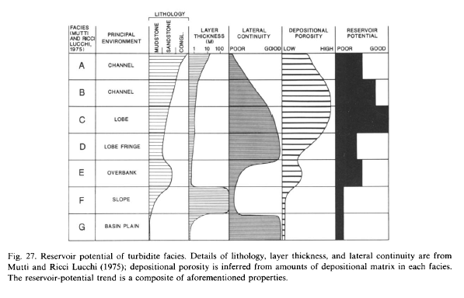

**Architectural and morphological characteristics:**

**Channels**

* display sinuous, ribbon–like geometries in plan–form and overall concave morphologies with irregular/erosional bases in vertical profile

**Lobes**

* generally show lobate geometries in plan–form and overall convex–up morphologies with flat bases in vertical profile
* have much higher width to thickness ratios than turbidite channels
* have great lateral extent and continuity yet relatively limited thickness ( unconfined environment)
* sand amalgamation increases the connectivity od the sand bodies
* Lobe complexes are bounded by pelagic/hemipelagic shales, several meters to tens of meters thick, implying long sedimentation hiatus.

**Factors controlling the turbidites:**

**Geometries** of turbidite are strongly controlled by the shape of the basin:

* Low slope to basin relief – specific to continental margins
  + Show pragradation of the turbidite system
* High slope to basin relief – specific to areas tectonically controlled
  + Show aggradation and retrogradation of the turbidite system
* Sea level is the primary factor controlling the growth of submarine fans. Submarine fans are associated typically with periods of low sea level.

Based on **efficiency to transport sand**, there are 2 types of fan system:

* Highly efficient
  + Turbidity currents of a *mud-rich system* transport sand efficiently over long distances
* Poorly efficient
  + The transport efficiency of a *sand-rich system* is relatively poor

|  |  |  |
| --- | --- | --- |
| **Characteristics** | **Highly efficient (Eocene Hecho system, Spain)** | **Poorly efficient** |
| **Sediment** | Mud rich | Sand rich |
| **Source area (size)** | Large | Restricted |
| **Sediment feeding system** | River - delta | Beach-canyon |
| **Size of fan** | Large (hundreds of km) | Small (tens of km) |
| **Gradient (slope)** | Low | High |
| **Distance of transport** | Long | Short |
| **Amount of fine in suspension** | Large | Small |
| **Channels** | Detached from lobes  Higher sinuosity | Attached to lobes  Low sinuosity |
| **Sandstone lobes** | Large | Small |
| **Lobe cycles** | Well developed, thickening upward trends | Poorly developed, thickening upward trends |
| **Zone of bypassing** | Present | Absent |
| **Lobe fringe deposits** | Well developed | Poorly developed or absent |
| **Basin plain deposits** | Well developed | Poorly developed or absent |
| **Net to gross** | Low | High |
| **Vertical connectivity of sand bodies** | Multiple reservoir – seal pairs | Amalgamation, vertical connectivity |